 | CHAMPIONNATS D’AFRIQUE  Alger (Algérie) du 07 au 13 Mai  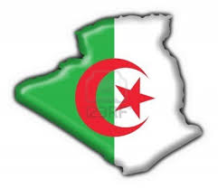  2022 Raffa Hommes | 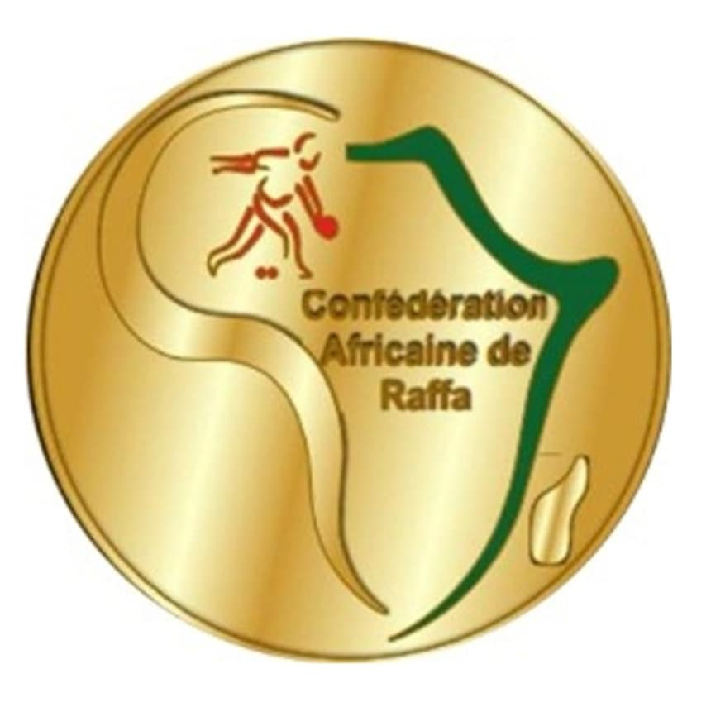

TIR DE PRECISION - TIRO DI PRECISIONE الرمي بالدقة -

QUALIFICATIONS
 |  |  | P. 1 | P. 2 | Qu. |  |  |  | P. 1 | P. 2 | Qu.
1. | ALG-1 | LAHMAR MUSTAPHA | 15 |  |  | 10. | TUNI | KHALIL JLASI | 02
2. | TCH | BRAHIM ALLADJABA | 01 |  |  | 11. | LES | MONETHI KAMOHELO | 05
3. | TOG | GABADOE FILLY | 00 |  |  | 12. | ALG-2 | ALI HAKIM | 18
4. | MOZ | PAUL TOMAS MAT | 00 |  |  | 13. | MAR | ARGUIL SAAD | 01
5. | OUG | YIGA HENRY | 05 |  |  | 14. | ZAM | KALIMA FRED | 02
6. | KEN | NJAGI KENEDY FU | 09 |  |  | 15. | LIBY | RACHED SOUICI | 15
7. | BUR | NIJIMBERE ATHANA | 00 |  |  | 16. | MAU | MOHAMED DIEYE | 09
8. | ZIM | WAZVAREMHAKA | 03 |  |  | 17.
9. | NIG | MUSHIN ALIYU OTH | 00 |  |  | 18.

DEMI - FINALES
 |  |  |  | Bar. |  |  |  |  | Bar.
1. | MAU | MOHAMED EL MOU |  | 9 | 4. |  | RACHED SOUICI | LIB | 14
2. | ALG1 | LAHMAR MUSTAPHA |  | 5 | 3. |  | ALI HAKIM | ALG2 | 16

FINALE
 |  |  |  | Bar. |  |  |  |  | Bar.
1. | LIB | RACHED SOUICI |  | 11 | 2. |  | ALI HAKIM | ALG2 | 23

1. |  | ALG2 | ALI HAKIM
2. |  | LIB | RACHED SOUICI
3. |  | ALG1  MAU | LAHMAR MUSTAPHA  MOHAMED EL MOU
IR DE PRECISION - TIRO D

