 | CHAMPIONNATS D’AFRIQUE  Alger (Algérie) du 07 au 13 Mai    2022 Raffa Garçons | 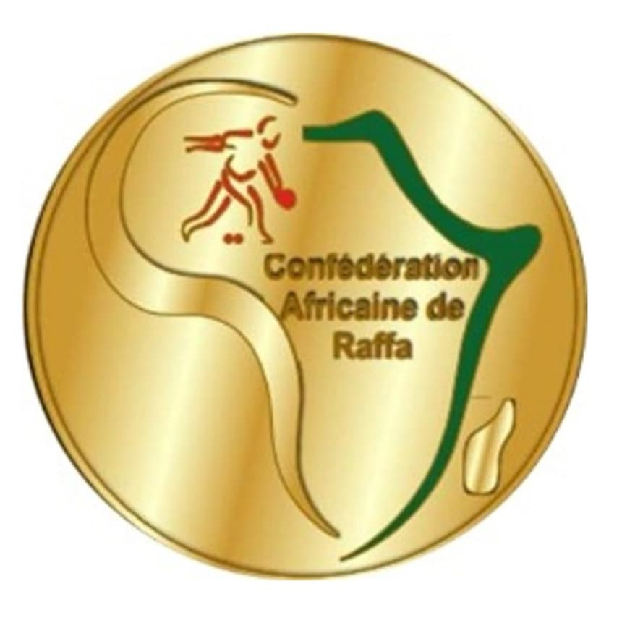

TIR DE PRECISION - TIRO DI PRECISIONE الرمي بالدقة -

QUALIFICATIONS
 |  |  | P. 1 | P. 2 | Qu. |  |  |  | P. 1 | P. 2 | Qu.
1. | TUN | OUSSAMA BALTI |  |  |  | 10.
2. | LIB | FRAS EL ZLITNI |  |  |  | 11.
3. | ALG-1 | HAMEL HOUSSAM |  |  |  | 12.
4. | ALG-2 | BADA HOUSSAM |  |  |  | 13.
5. |  |  |  |  |  | 14.
6. |  |  |  |  |  | 15.
7. |  |  |  |  |  | 16.
8. |  |  |  |  |  | 17.
9. |  |  |  |  |  | 18.

DEMI - FINALES
 |  |  |  | Bar. |  |  |  |  | Bar.
1. | ALG-1 | HAMEL HOUSSAM | 10 |  | 4. |  | BADA HOUSSAM | ALG-2 | 03
2. | TUN | OUSSAMA BALTI | 15 |  | 3. |  | FRAS EL ZLITNI | LIB | 09

FINALE
 |  |  |  | Bar. |  |  |  |  | Bar.
1. | ALG-1 | HAMEL HOUSSAM | 16 |  | 2. |  | OUSSAMA BALTI | TUN | 02

1. |  | ALG-1 | HAMEL HOUSSAM
2. |  | TUN | OUSSAMA BALTI
3. |  | ALG-2  LIB | BADA HOUSSAM  FRAS EL ZLITNI

