 | CHAMPIONNATS D’AFRIQUE  Alger (Algérie) du 07 au 13 Mai  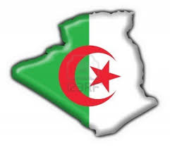  2022 Raffa Hommes | 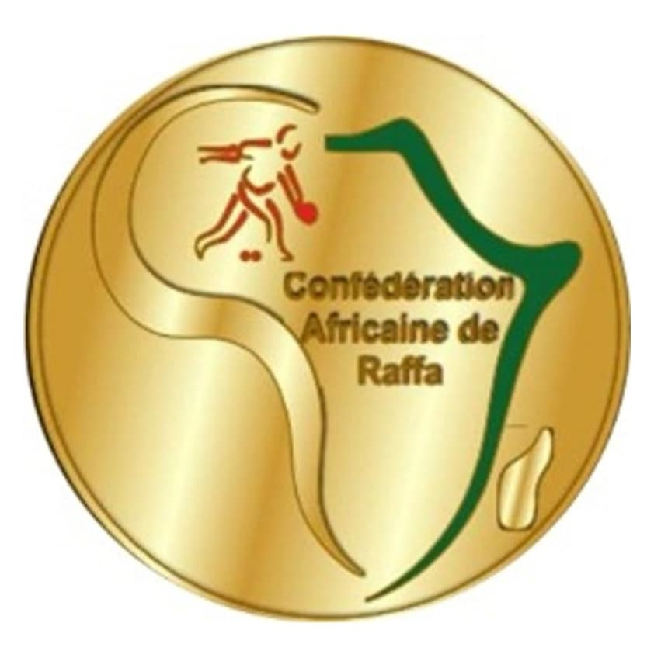

DOUBLE – COPPIE الثنائي -

POULE I | 1ère Phase | MAR | ARGUIEL S + EL MOUSTAFID | 09 | 10 | KALIMA FRED  KALONGA GODFREY | ZAM
POULE I | 1ère Phase | NIG | ISRAEL MED ABDULLAHI  MUSHIN ZLIYU OTHMAN | 04 | 12 | SERGIO JULIETA SITOE  PAUL TOMAS MATOLA | MOZ
POULE I | 2e Phase | ZAM | KALIMA FRED  KALONGA GODFREY | 09 | 08 | SERGIO JULIETA SITOE  PAUL TOMAS MATOLA | MOZ
POULE I | 2e Phase | MAR | ARGUIEL SAAD  EL MOUSTAFID ABDELDJALIL | 12 | 00 | ISRAEL MED ABDULLAHI  MUSHIN ZLIYU OTHMAN | NIG
POULE I | Barrage | MOZ | SERGIO JULIETA SITOE  PAUL TOMAS MATOLA | 00 | 12 | ARGUIEL SAAD  EL MOUSTAFID ABDELDJALIL | MAR
POULE I | Classement | 1er: ZAM : WAZVAREMHAKA EDGAR  MAGADZA TERENCE |  |  | 2eme: MAR : ARGUIEL SAAD  EL MOUSTAFID ABDELDJALIL

POULE II | 1ère Phase | LIB | RACHED SOUISSI  MAHMOUD AISSI | 04 | 12 | ALI HAKIM  TRIAKI AHMED | ALG-2
POULE II | 1ère Phase | LST | MONETHI KAMOHELO FLEX  MPOLOKENG MAKOALA | 07 | 12 | IBRAHIM ALLADJABA  DJI-ALLATI NADEYEM | TCH
POULE II | 2e Phase | ALG-2 | ALI HAKIM  TRIAKI AHMED | 12 | 03 | IBRAHIM ALLADJABA  DJI-ALLATI NADEYEM | TCH
POULE II | 2e Phase | LIB | RACHED SOUISSI  MAHMOUD AISSI | 12 | 01 | MONETHI KAMOHELO FLEX  MPOLOKENG MAKOALA PRECIOS | LST
POULE II | Barrage | TCH | IBRAHIM ALLADJABA  DJI-ALLATI NADEYEM | 00 | 12 | RACHED SOUISSI  MAHMOUD AISSI | LIB
POULE II | Classement | 1er : ALG -2 : ALI HAKIM  TRIAKI AHMED |  |  | 2eme: LIB : RACHED SOUISSI  MAHMOUD AISSI

POULE III | 1ère Phase | TUN | KHALIL DJELASSI  OUSSAMA BALTI | 12 | 00 | AGBEDJINOU KHODJO  GBADOE FOLLY RUDEL-VARTAN | TOG
POULE III | 1ère Phase | MAU | DIEYE MOHAMED  TALEBNE MOHAMED MAHMOUD | 04 | 12 | IRAKOZ IGORE KEVIN  NIJIMBERE ATHNASE | BUR
POULE III | 2e Phase | TUN | KHALIL DJELASSI  OUSSAMA BALTI | 12 | 06 | IRAKOZ IGORE KEVIN  NIJIMBERE ATHNASE | BUR
POULE III | 2e Phase | TOG | AGBEDJINOU KHODJO  GBADOE FOLLY RUDEL-VARTAN | 00 | 12 | DIEYE MOHAMED  MOHAMED EL MOSTAPHA | MAU
POULE III | Barrage | BUR | IRAKOZ IGORE KEVIN  NIJIMBERE ATHNASE | 03 | 12 | DIEYE MOHAMED  MOHAMED EL MOSTAPHA | MAU
POULE III | Classement | 1er: TUN : KHALIL DJELASSI  OUSSAMA BALTI |  |  | 2eme: MAU : DIEYE MOHAMED  MOHAMED EL MOSTAPHA

POULE IV | 1ère Phase | ALG-1 | ZEKIRI TAREK  LAHMAR MUSTAPHA | 12 | 00 | YIGA HENRI  MBENTYO BAKER | OUG
POULE IV | 1ère Phase | ZIM | WAZVAREMHAKA EDGAR  MAGADZA TERENCE | 07 | 12 | KEVIN MAWSARU MWABILI  NJAGI KENEDY FUNDI | KEN
POULE IV | 2e Phase | ALG-1 | ZEKIRI TAREK  LAHMAR MUSTAPHA | 12 | 00 | KEVIN MAWSARU MWABILI  NJAGI KENEDY FUNDI | KEN
POULE IV | 2e Phase | OUG | YAGA HENRI  MBENTYO BAKER | 06 | 12 | WAZVAREMHAKA EDGAR  MAGADZA TERENCE | ZIM
POULE IV | Barrage | KEN | KEVIN MAWSARU MWABILI  NJAGI KENEDY FUNDI | 12 | 09 | WAZVAREMHAKA EDGAR  MAGADZA TERENCE | ZIM
POULE IV | Classement | 1er: ALG-1 : ZEKIRI TAREK  LAHMAR MUSTAPHA |  |  | 2eme: KEN : KEVIN MAWSARU MWABILI  NJAGI KENEDY FUNDI

DOUBLE - COPPIE

QUARTS  de FINALE | ZAM | WAZVAREMHAKA EDGAR  MAGADZA TERENCE | 12 | 03 | KEVIN MAWSARU MWABILI  NJAGI KENEDY FUNDI | KEN
QUARTS  de FINALE | ALG-2 | ALI HAKIM  TRIAKI AHMED | 12 | 00 | DIEYE MOHAMED  MOHAMED EL MOSTAPHA | MAU
QUARTS  de FINALE | TUN | KHALIL DJELASSI  OUSSAMA BALTI | 06 | 12 | RACHED SOUISSI  MAHMOUD AISSI | LIB
QUARTS  de FINALE | ALG-1 | ZEKIRI TAREK  LAHMAR MUSTAPHA | 09 | 08 | ARGUIEL SAAD  EL MOUSTAFID ABDELDJALIL | MAR

CLASSEM.^{T}
3° à 4°

DEMI -FINALES | ALG-1 | ZEKIRI TAREK  LAHMAR MUSTAPHA | 12 | 07 | ALI HAKIM  TRIAKI AHMED | ALG-2
DEMI -FINALES | LIB | RACHED SOUISSI  MAHMOUD AISSI | 12 | 01 | WAZVAREMHAKA EDGAR  MAGADZA TERENCE | ZAM

FINALE | ALG-1 | ZEKIRI TAREK  LAHMAR MUSTAPHA | 12 | 06 | RACHED SOUISSI  MAHMOUD AISSI | LIB

PODIUM

1. |  | ALG-1 | ZEKIRI TAREK  LAHMAR MUSTAPHA
2. |  | LIB | RACHED SOUISSI  MAHMOUD AISSI
3. |  | ALG-2  ZAM | ALI HAKIM  TRIAKI AHMED  WAZVAREMHAKA EDGAR  MAGADZA TERENCE

