 | CHAMPIONNATS D’AFRIQUE  Alger (Algérie) du 07 au 13 Mai  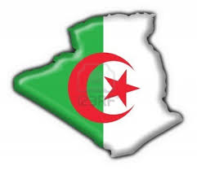  2022 Raffa Mixte Seniors | 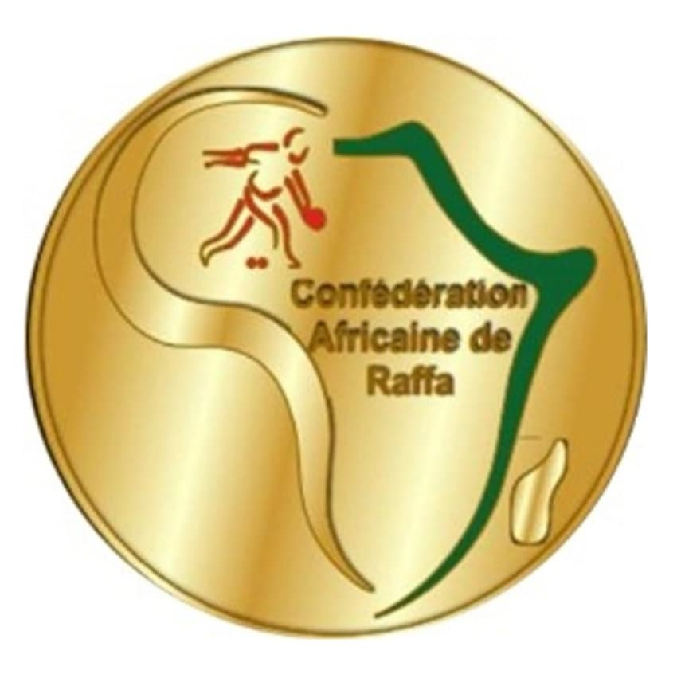

DOUBLE Mixte– COPPIE الثنائي مختلط -

POULE I | 1ère Phase | ALG-1 | LAHMAR + CHIBANI | 12 | 00 | MOISES SIMBAI +  SAN DA LUCIA | MOZ
POULE I | 1ère Phase | TCH | DJI-ALLATI +  KHADIDJA HASSAN
POULE I | 2e Phase | TCH | DJI-ALLATI +  KHADIDJA HASSAN | 02 | 12 | LAHMAR + CHIBANI | ALG-1
POULE I | Barrage | MOZ | MOISES SIMBAI +  SAN DA LUCIA | 12 | 05 | DJI-ALLATI +  KHADIDJA HASSAN | TCH
POULE I | Classement | 1er: ALG1 : LAHMAR + CHIBANI |  |  | 2eme: MOZ : MOISES SIMBAI +  SAN DA LUCIA

POULE II | 1ère Phase | LIB | MAHMOUD + NADJAH | 12 | 01 | GGBADOE FOLLY +  AMEGAVI-JHONE | TOG
POULE II | 1ère Phase | LES | MONETHI KAMOHELO +  RAMOKHORO KARABO
POULE II | 2e Phase | LES | MONETHI KAMOHELO +  RAMOKHORO KARABO | 03 | 12 | MAHMOUD + NADJAH | LIB
POULE II | 2e Phase | TOG | GGBADOE FOLLY +  AMEGAVI-JHONE
POULE II | Barrage | TOG | GGBADOE FOLLY +  AMEGAVI-JHONE | 07 | 12 | MONETHI KAMOHELO +  RAMOKHORO KARABO | LES
POULE II | Classement | 1er: LIB : MAHMOUD + NADJAH |  |  | 2eme: LES : MONETHI KAMOHELO +  RAMOKHORO KARABO

POULE III | 1ère Phase | TUN | KHALIL+ SABRINE | 12 | 03 | MBENTYO + NALUKENGE | OUG
POULE III | 1ère Phase | ALG-2 | AMARI +TRIAKI
POULE III | 2e Phase | ALG-2 | AMARI +TRIAKI | 12 | 05 | KHALIL+ SABRINE | TUN
POULE III | Barrage | OUG | MBENTYO + NALUKENGE | 01 | 12 | KHALIL+ SABRINE | TUN
POULE III | Classement | 1er: ALG-2 : AMARI +TRIAKI |  |  | 2eme: TUN : KHALIL+ SABRINE

POULE IV | 1ère Phase | MAR | EL MOUSTAFID ABDELDJALIL  EL MZAMZI EL IDRISSI SARA | 12 | 07 | NIJIMBERE ATHANASE  SHIMWE RITA BERENICE | BUR
POULE IV | 1ère Phase | ZAM | KALIMA FRED  PHIRI FATIMA | 09 | 08 | NJAGI KENEDY FUNDI  MAWLEWA WINNIE MAWANGEMI | KEN
POULE IV | 2e Phase | ZAM | KALIMA FRED  PHIRI FATIMA | 03 | 12 | OUINAKSI +  LEFHALEL ALLAOUI | MAR
POULE IV | 2e Phase | BUR | NIJIMBERE ATHANASE  SHIMWE RITA BERENICE | 09 | 05 | NJAGI KENEDY FUNDI  MAWLEWA WINNIE MAWANGEMI | KEN
POULE IV | Barrage | BUR | NIJIMBERE ATHANASE  SHIMWE RITA BERENICE | 06 | 12 | KALIMA FRED  PHIRI FATIMA | ZAM
POULE IV | Classement | 1er: MAR : OUINAKSI +  LEFHALEL ALLAOUI |  |  | 2eme: ZAM : KALIMA FRED  PHIRI FATIMA

DOUBLE - COPPIE

QUARTS  de FINALE | ALG-1 | LAHMAR + CHIBANI | 12 | 04 | KALIMA FRED  PHIRI FATIMA | ZAM
QUARTS  de FINALE | LIB | MAHMOUD + NADJAH | 06 | 09 | KHALIL+ SABRINE | TUN
QUARTS  de FINALE | ALG-2 | AMARI +TRIAKI | 12 | 02 | MONETHI KAMOHELO +  RAMOKHORO KARABO | LES
QUARTS  de FINALE | MAR | OUINAKSI +  LEFHALEL ALLAOUI | 09 | 04 | MOISES SIMBAI +  SAN DA LUCIA | MOZ

CLASSEM.^{T}
3° à 4°

DEMI -FINALES | ALG-2 | AMARI +TRIAKI | 08 | 12 | LAHMAR + CHIBANI | ALG-1
DEMI -FINALES | MAR | EL MOUSTAFID,A+ EL MZAMZI ,S | 07 | 12 | JLASSI ,KHALIL+ ZEKRI ,SABRINE | TUN

FINALE | ALG-1 | LAHMAR MUSTAPHA  CHIBANI CHARAZED | 12 | 01 | JLASSI KHALIL  ZEKRI SABRINE | TUN

PODIUM

1. |  | ALG-1 | LAHMAR MUSTAPHA  CHIBANI CHARAZED
2. |  | TUN | JLASSI KHALIL  ZEKRI SABRINE
3. |  | ALG-1  MAR | AMARI FOUZIA  TRIAKI AHMED  EL MOUSTAFID ABDELDJALIL  EL MZAMZI EL IDRISSI SARA

